**Module 13: Course Project**

**Project Step 2: Data Analysis**

**Group Team 11**

Dhaval Jitendrakumar Ghinaiya

Krutali Virenbhai Thakkar

Alay BrijeshKumar Patel

Hitaxi Jayantilal Kachhadiya

MS in Information Technology, Arizona State University

IFT 511 - Analysing Big Data

April 27th , 2025

**Task 2: Discovering User Groups**

import pandas as pd

from sklearn.cluster import KMeans, DBSCAN, AgglomerativeClustering

from sklearn.preprocessing import StandardScaler

from collections import Counter

import os

from scipy.sparse import csr_matrix

import numpy as np

ratingData = pd.read_csv('Ratings.csv', delimiter=';', dtype={'User-ID': str, 'ISBN': str}, low_memory=False)

userData = pd.read_csv('Users.csv', delimiter=';', dtype={'User-ID': str}, low_memory=False)

bookData = pd.read_csv('Books.csv', delimiter=';', dtype={'ISBN': str}, low_memory=False)

mergeData = ratingData.merge(userData, on='User-ID').merge(bookData, on='ISBN')

minRating = 50

countOfBooks = mergeData['ISBN'].value_counts()

mergeData = mergeData[mergeData['ISBN'].isin(countOfBooks[countOfBooks >= minRating].index)]

userCount = mergeData['User-ID'].value_counts()

mergeData = mergeData[mergeData['User-ID'].isin(userCount[userCount >= minRating].index)]

userMatrix = mergeData.pivot_table(index='User-ID', columns='ISBN', values='Rating', fill_value=0)

userId = userMatrix.index

bookList = userMatrix.columns

sparseMatrix = csr_matrix(userMatrix.values)

scaler = StandardScaler(with_mean=False)

scaledUserMatrix = scaler.fit_transform(sparseMatrix)

os.makedirs("FinalOutputs", exist_ok=True)

def saveClusterBooks(cluster_labels, method_name, k_value=None):

results = []

mergeData_clusters = pd.DataFrame({'User-ID': userId, 'cluster': cluster_labels})

for cluster_id in sorted(np.unique(cluster_labels)):

if cluster_id == -1:

continue

cluster_users = mergeData_clusters[mergeData_clusters['cluster'] == cluster_id]['User-ID']

cluster_ratings = mergeData[mergeData['User-ID'].isin(cluster_users)]

top_books = cluster_ratings['ISBN'].value_counts().head(10)

header = f"{method_name}, Cluster {cluster_id}" + (f", k={k_value}" if k_value else "")

results.append(header)

for ISBN, count in top_books.items():

title_row = bookData[bookData['ISBN'] == ISBN]

book_title = title_row['Title'].values[0] if not title_row.empty else "Unknown Title"

results.append(f" {book_title}, {count}")

results.append("")

return "\n".join(results)

for k in [2, 4, 6, 8, 10, 20, 30]:

kmeans = KMeans(n_clusters=k, random_state=42)

labels = kmeans.fit_predict(scaledUserMatrix)

text = saveClusterBooks(labels, "KMeans", k)

with open(f"FinalOutputs/kmeans_k{k}.txt", "w") as f:

f.write(text)

denseMatrix = scaledUserMatrix.toarray()

for k in [2, 4, 6, 8, 10, 20, 30]:

hc = AgglomerativeClustering(n_clusters=k)

labels = hc.fit_predict(denseMatrix)

text = saveClusterBooks(labels, "Hierarchical", k)

with open(f"FinalOutputs/hierarchical_k{k}.txt", "w") as f:

f.write(text)

dbscan = DBSCAN(eps=0.3, min_samples=5)

labelDbscan = dbscan.fit_predict(scaledUserMatrix)

with open("FinalOutputs/dbscan.txt", "w") as f:

f.write(saveClusterBooks(labelDbscan, "DBSCAN"))

print("Task Complete. Results saved in 'FinalOutputs'.")

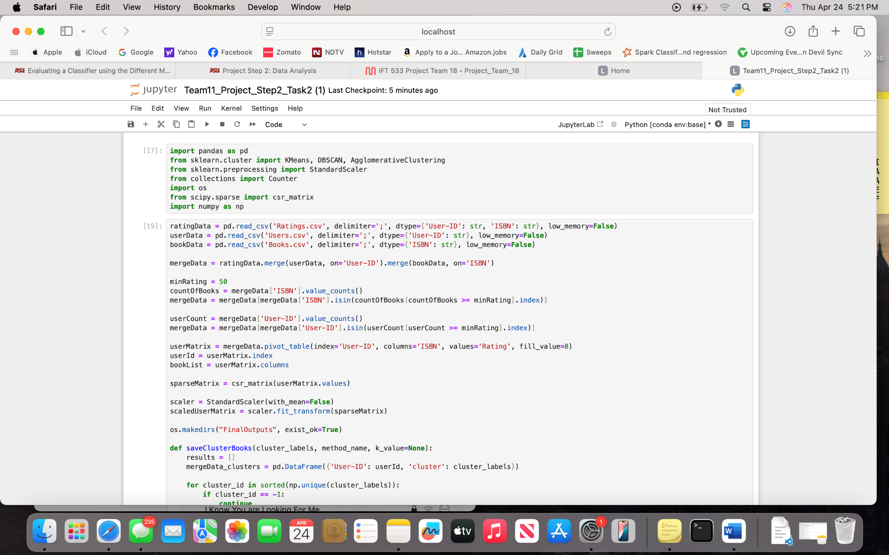

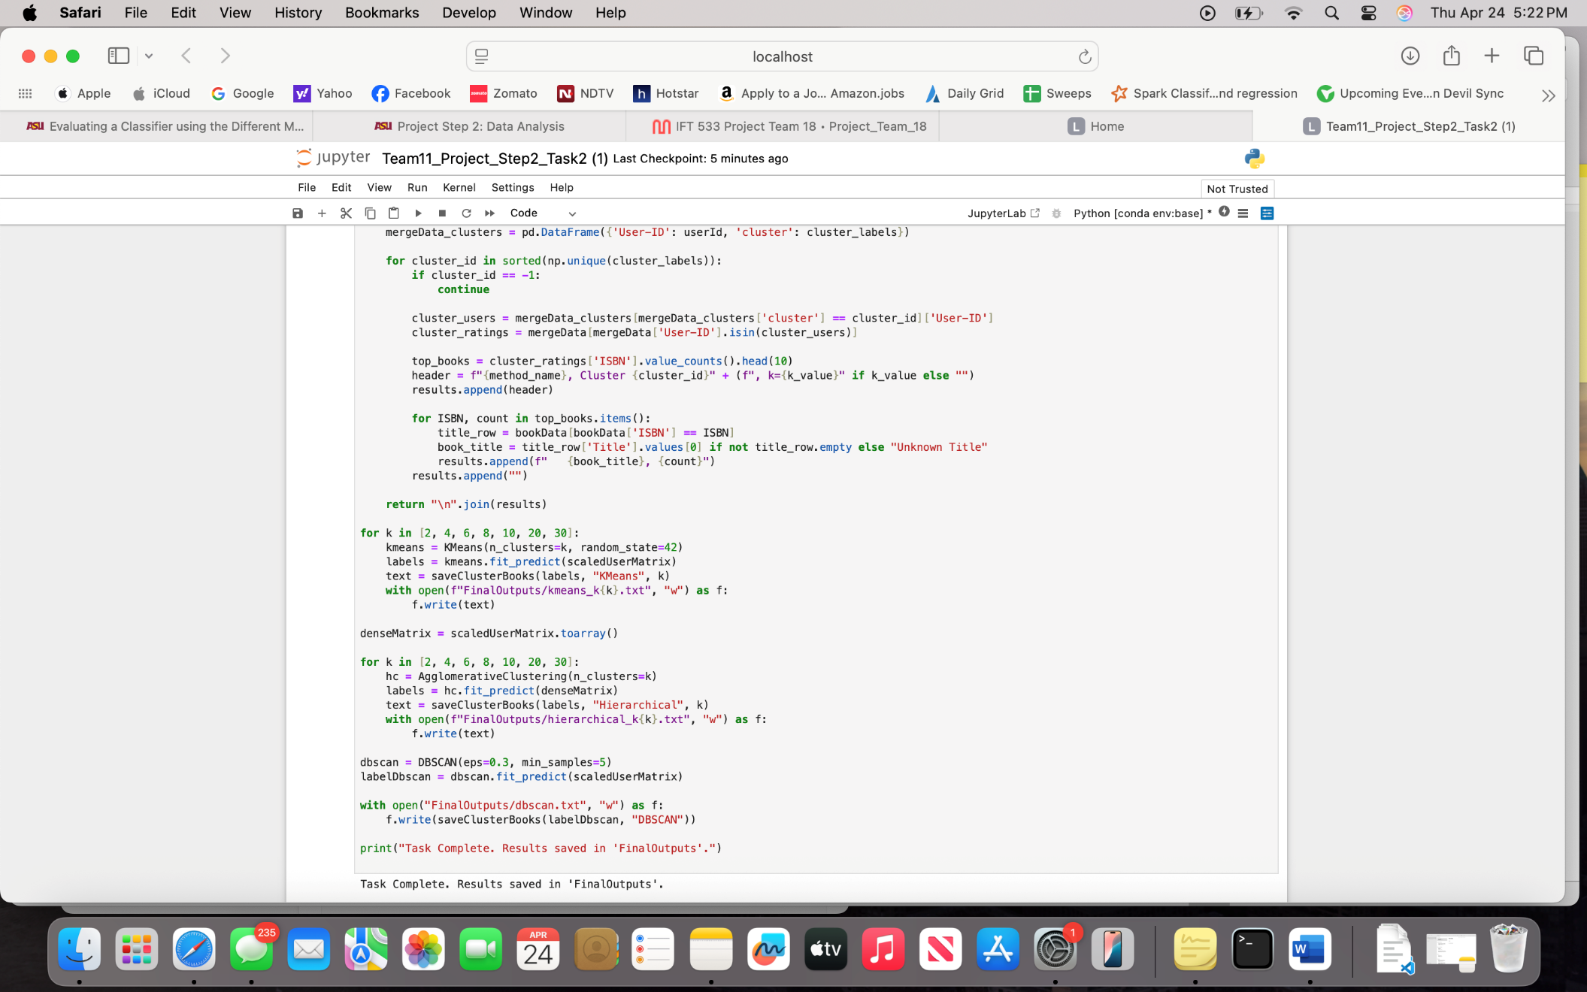

**Obtained Result**: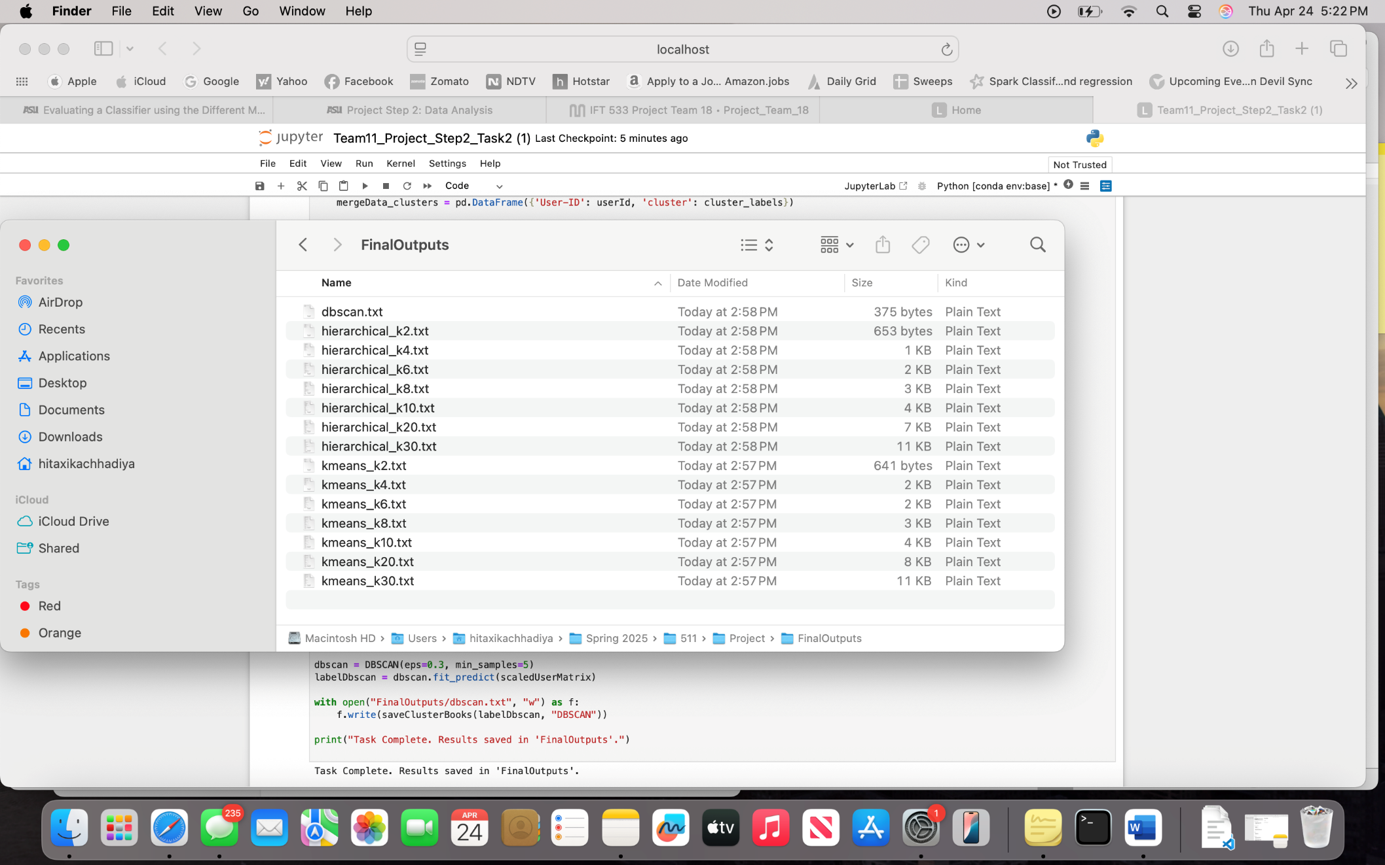

**DBSCAN Clustering:**

DBSCAN is a method used to find groups in data. But instead of forcing the data into a set number of groups, DBSCAN looks for areas where lots of points are close together these are considered dense areas. one of those groups might be people who all like the same types of books.

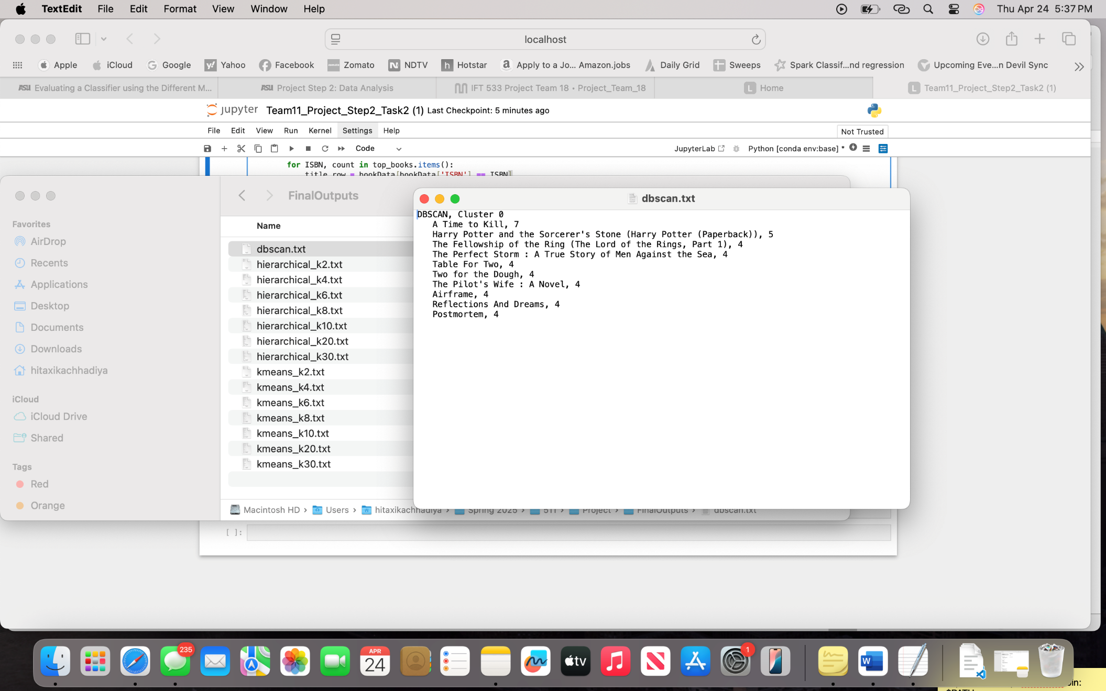

Hierarchical Clustering K= 2

Cluster 0, These are very popular books that many people read and rated. Cluster 1, These books got very few ratings.

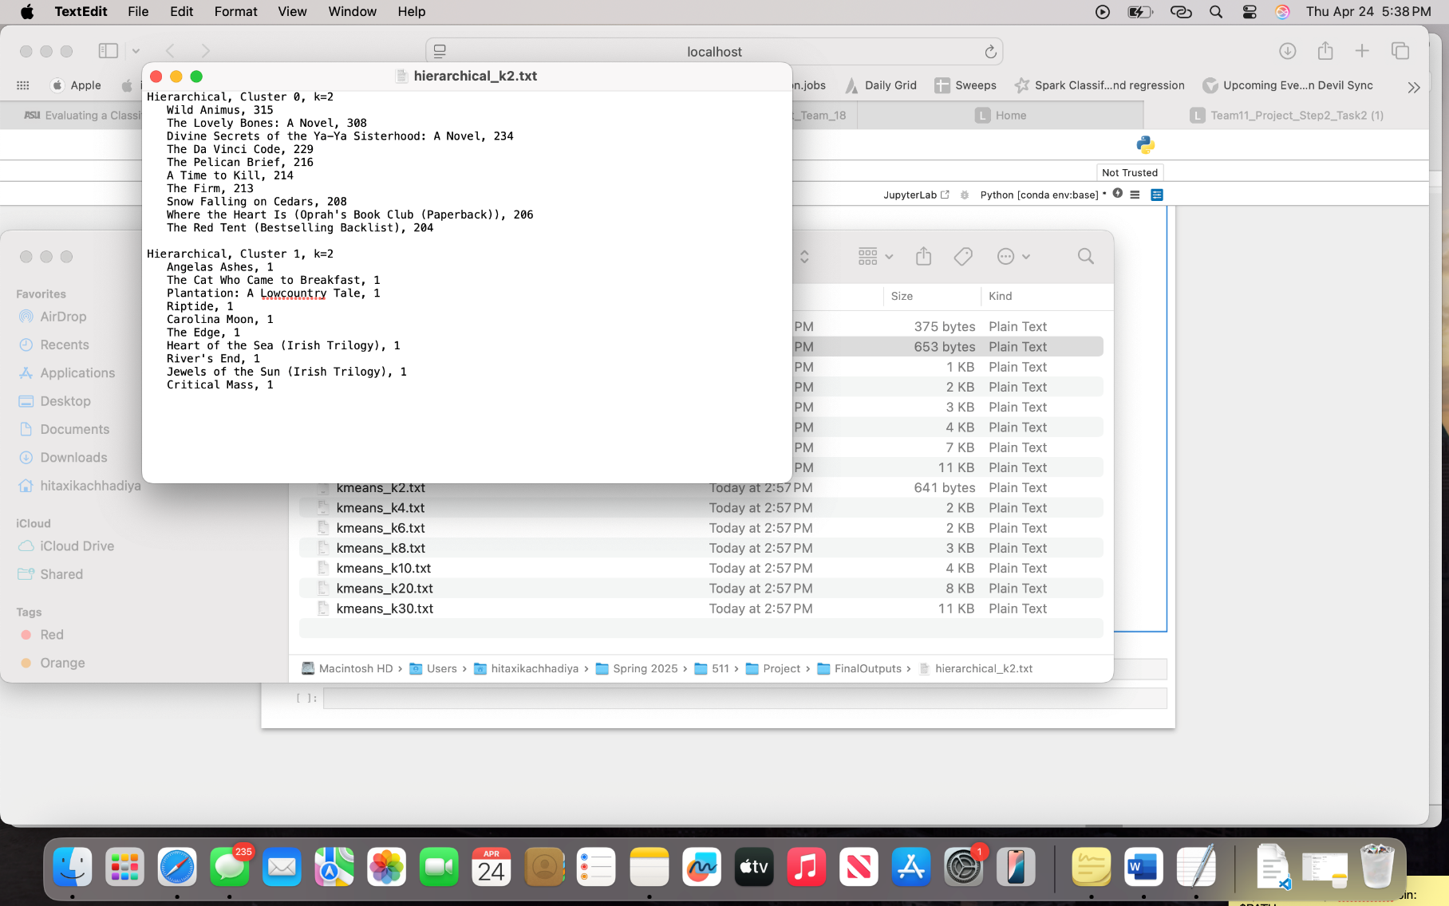

Hierarchical Clustering K= 4: Clusters 0 to 4 range from very popular books that many people read and rated to books that received very few ratings.

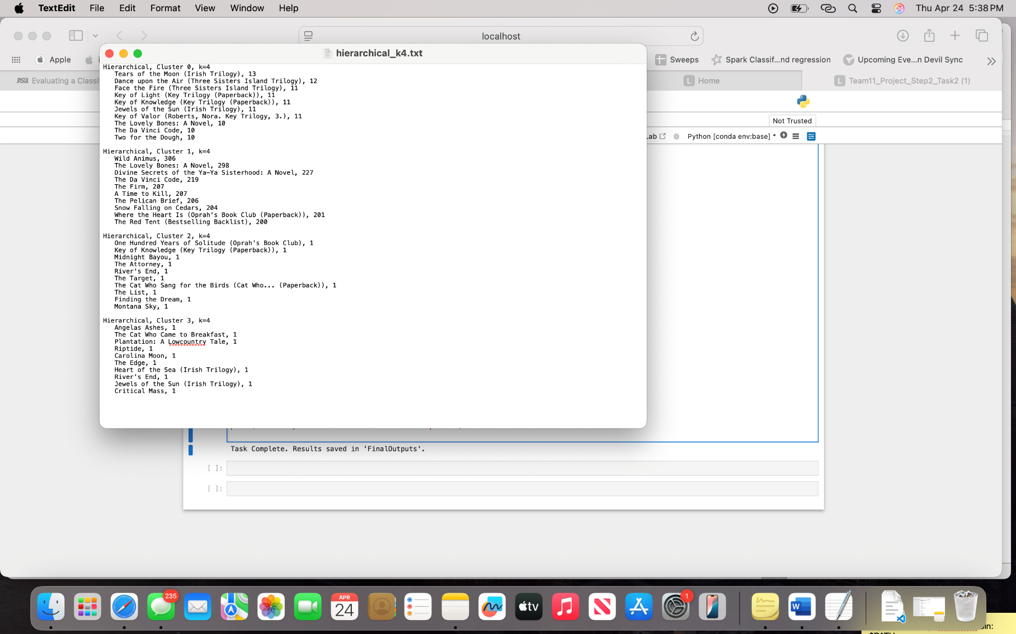

Hierarchical Clustering K= 6: Clusters 0 to 6 range from very popular books that many people read and rated to books that received very few ratings.

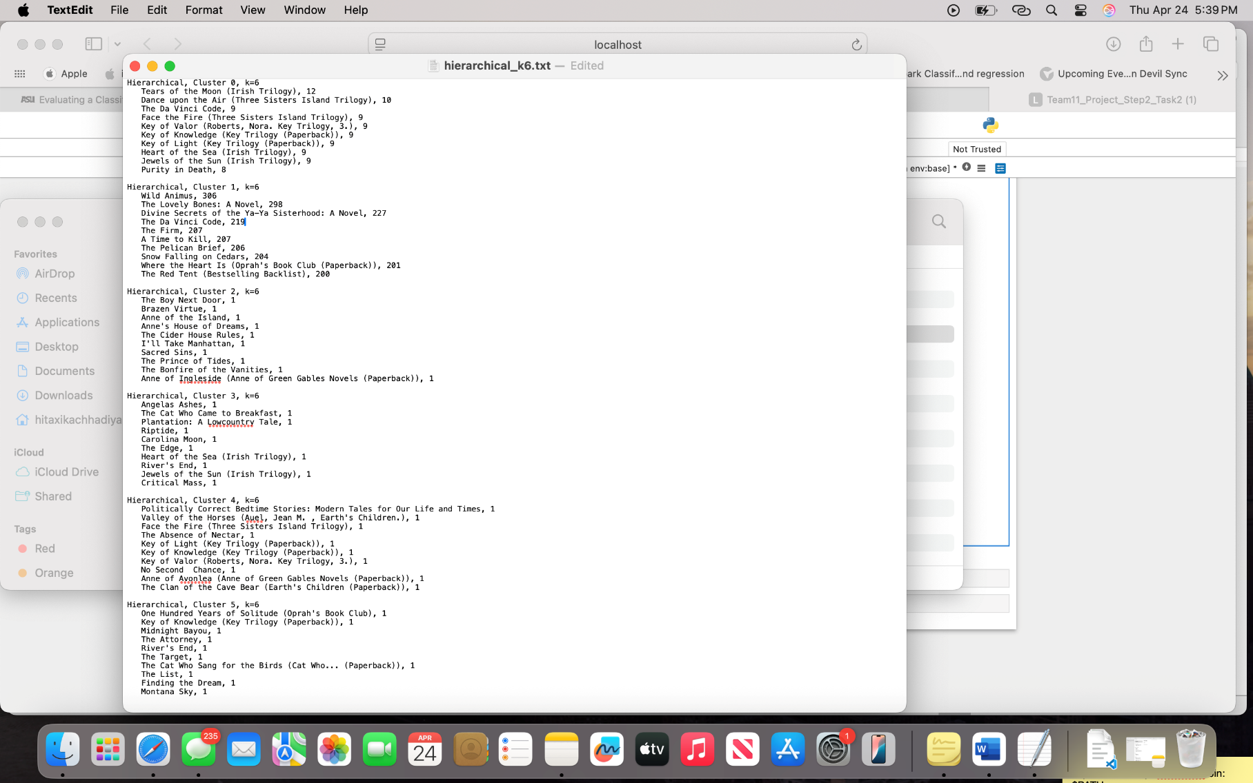

Hierarchical Clustering K= 8: Clusters 0 to 8 range from very popular books that many people read and rated to books that received very few ratings

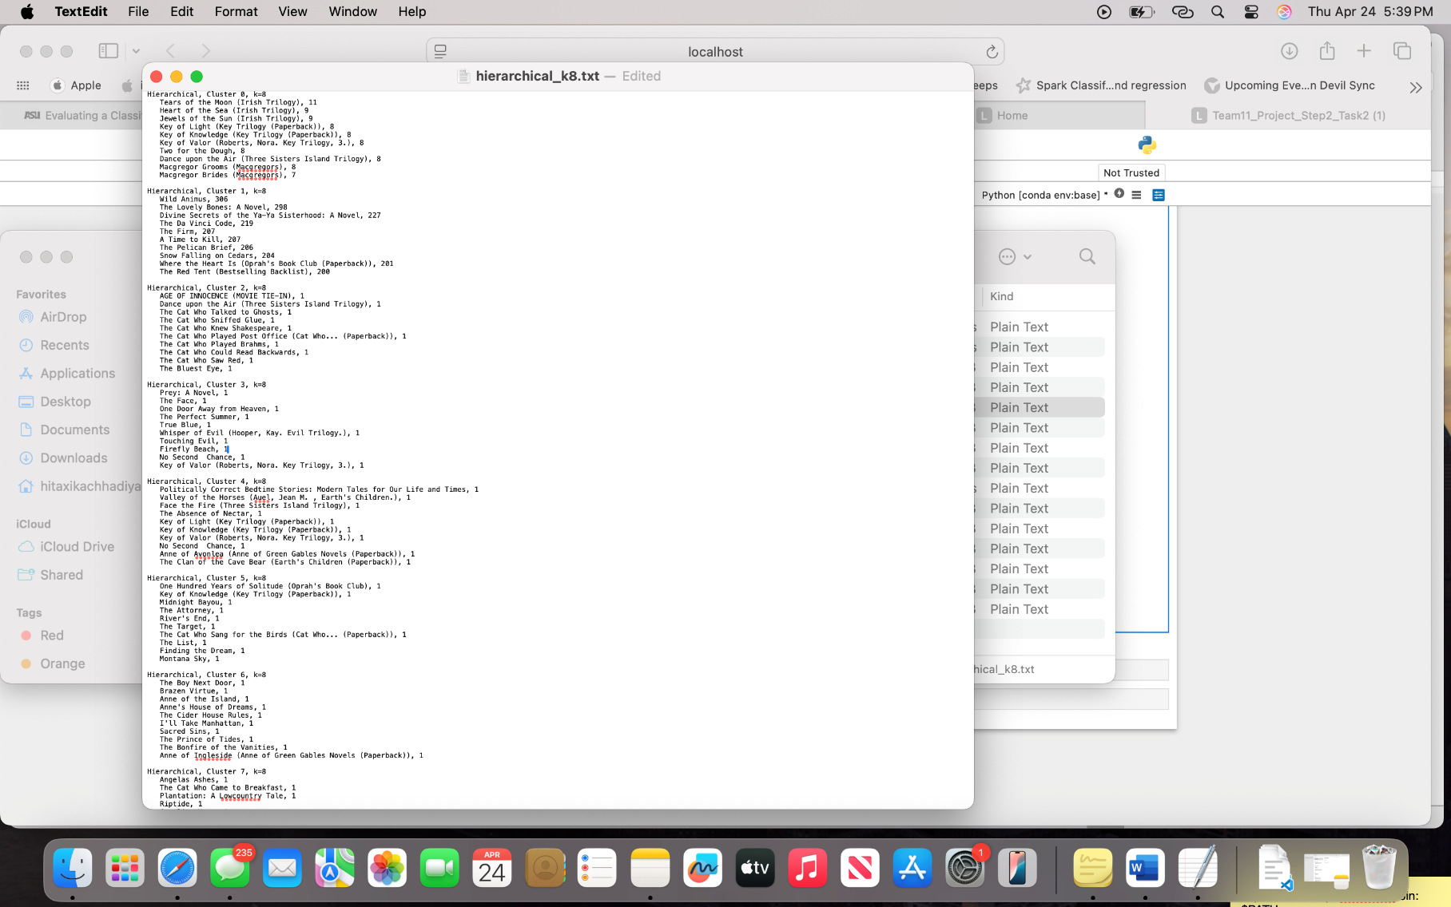

Hierarchical Clustering K= 10: Clusters 0 to 10 range from very popular books that many people read and rated to books that received very few ratings

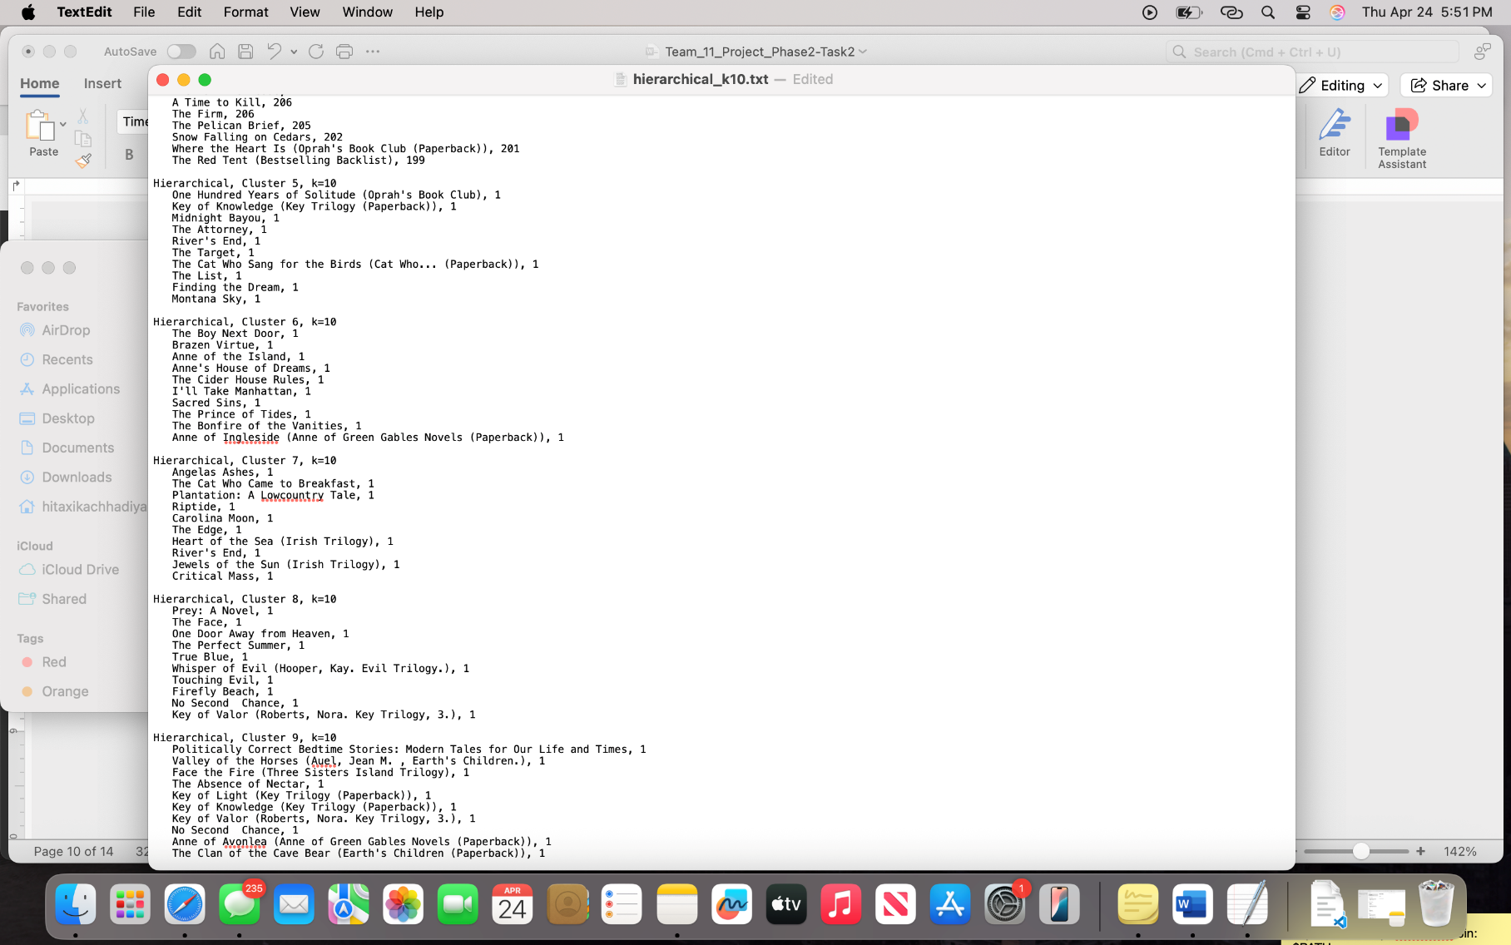

Hierarchical Clustering K= 20: Clusters 0 to 20 range from very popular books that many people read and rated to books that received very few ratings

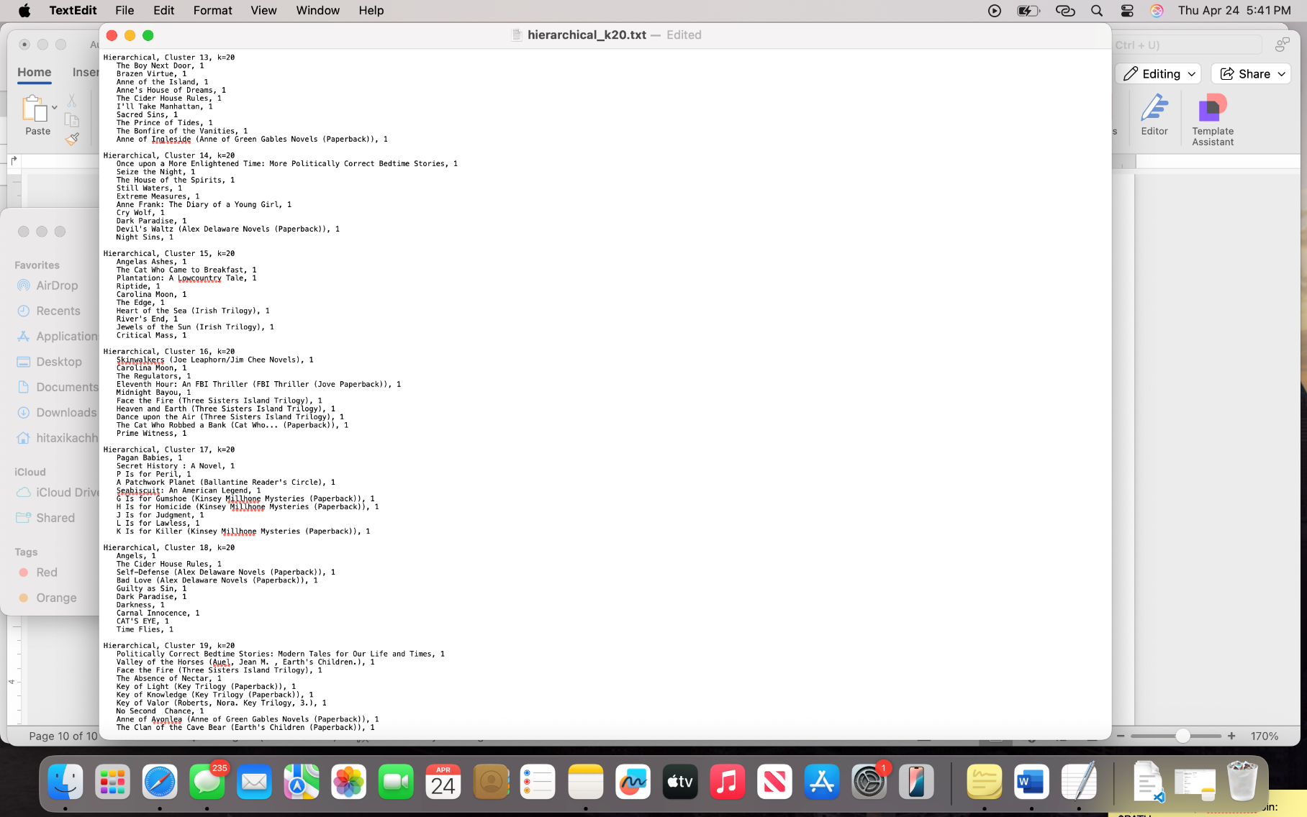

Hierarchical Clustering K= 30: Clusters 0 to 30 range from very popular books that many people read and rated to books that received very few ratings

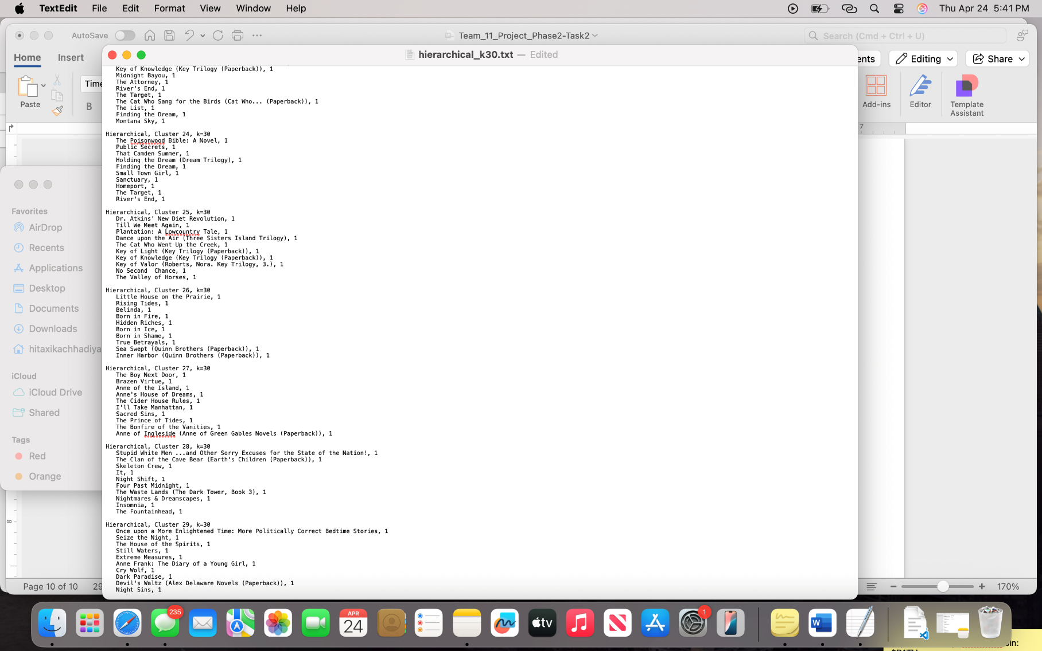

KMeans Clustering K= 2: Cluster 1, These are very popular books that many people read and rated. Cluster 0, These books got very few ratings.

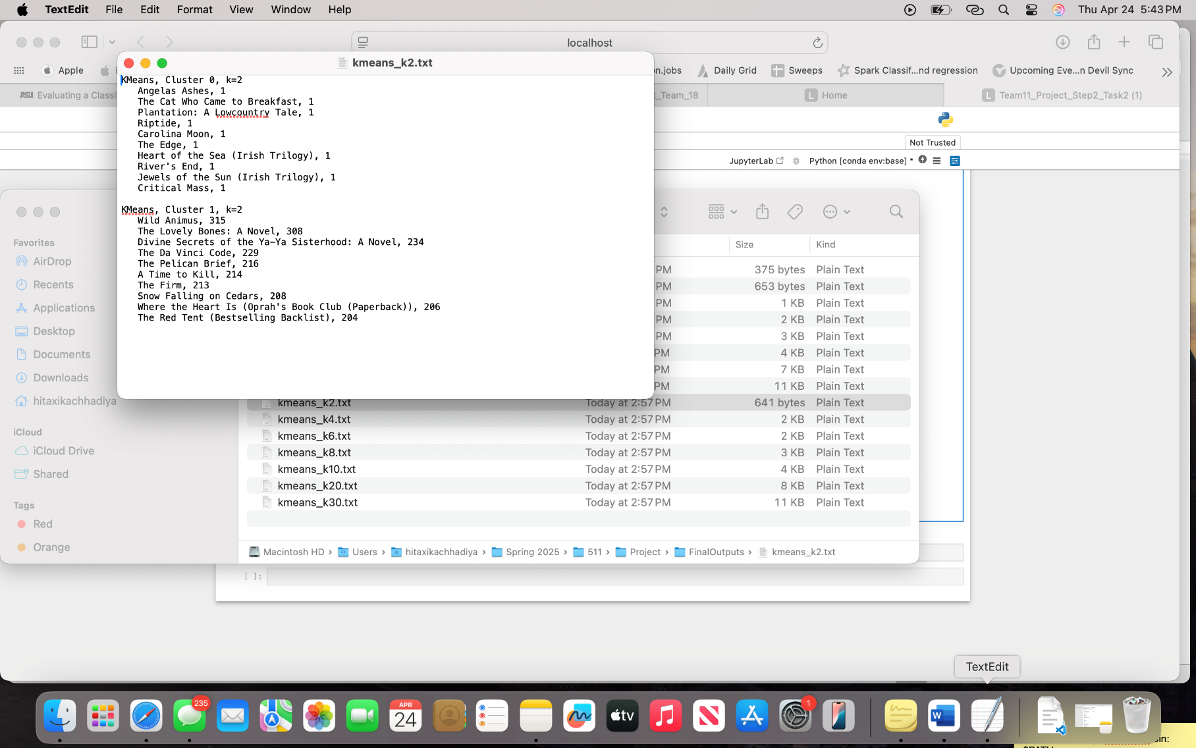

KMeans Clustering K= 4: Clusters 0 to 4 range from books that received very few ratings to very popular books that many people read and rated.

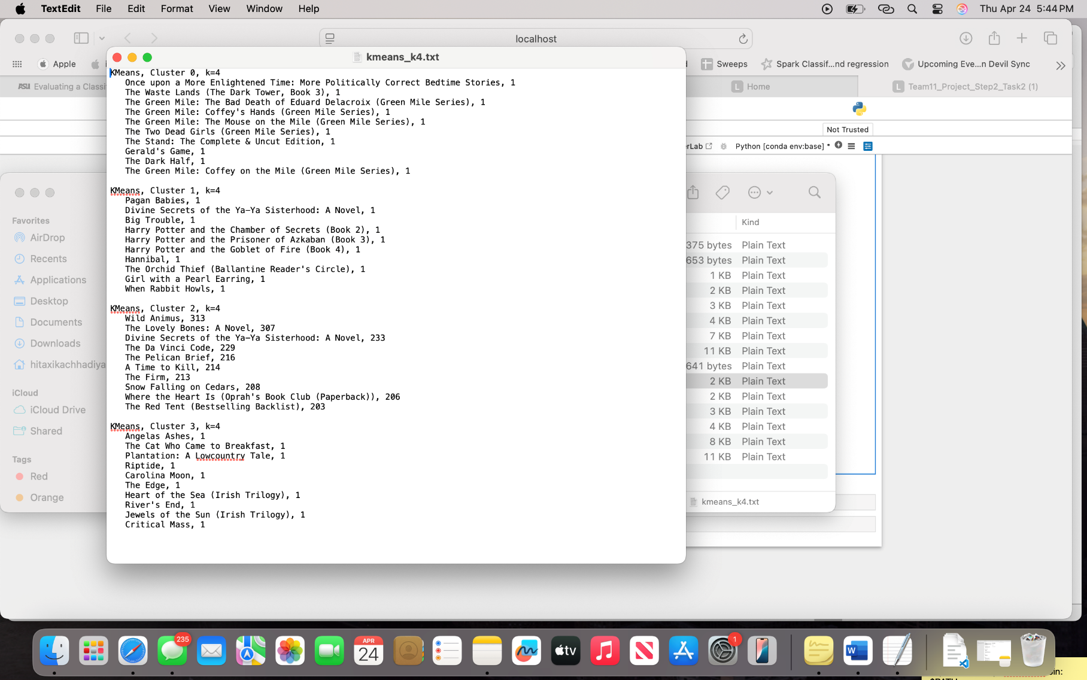

KMeans Clustering K= 6: Clusters 0 to 6 range from books that received very few ratings to very popular books that many people read and rated.

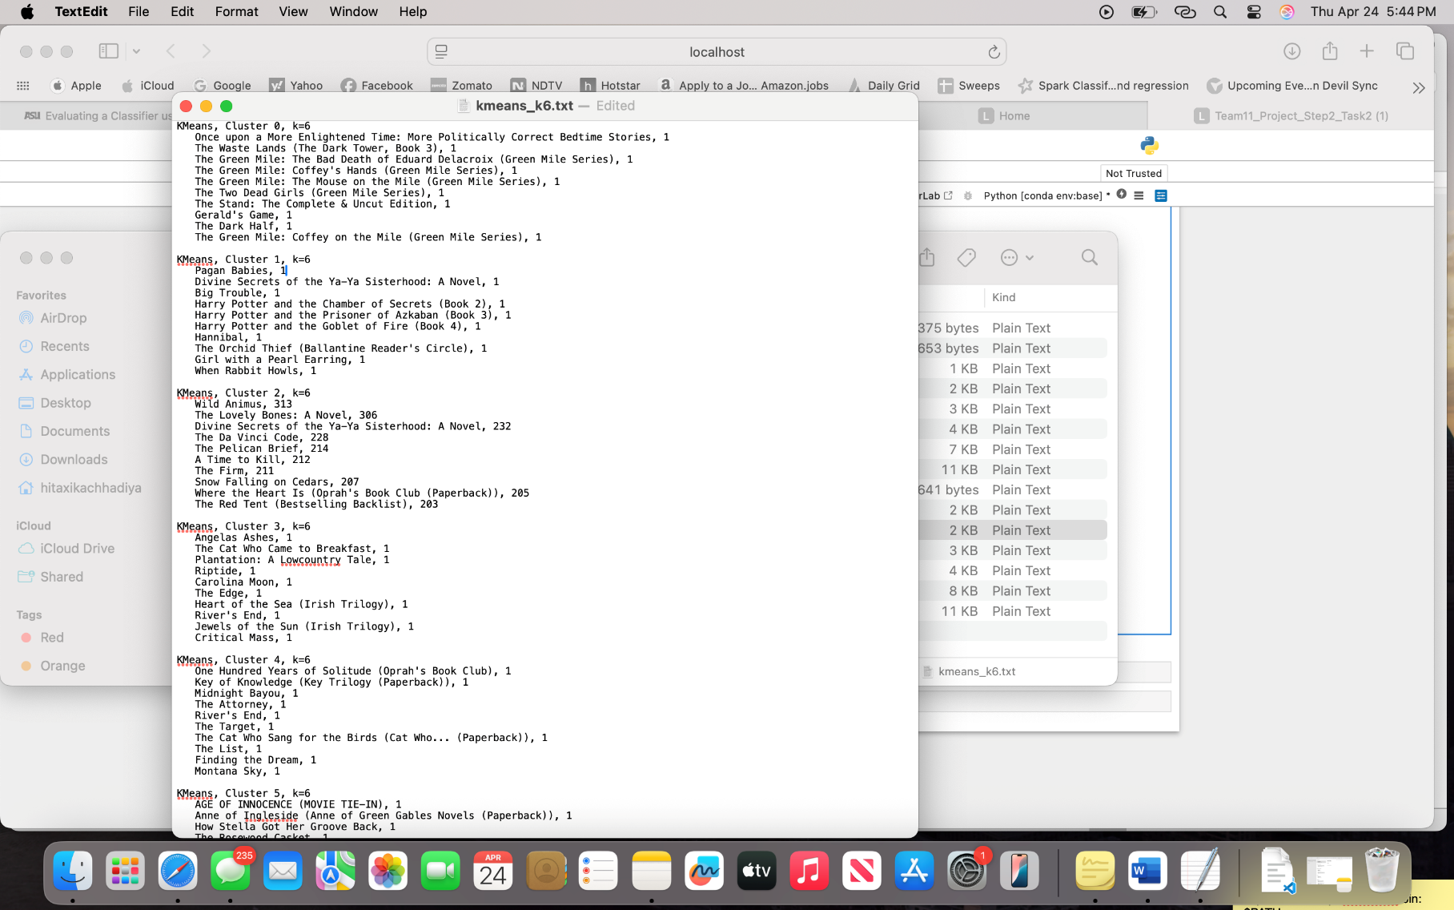

KMeans Clustering K= 8: Clusters 0 to 8 range from books that received very few ratings to very popular books that many people read and rated.

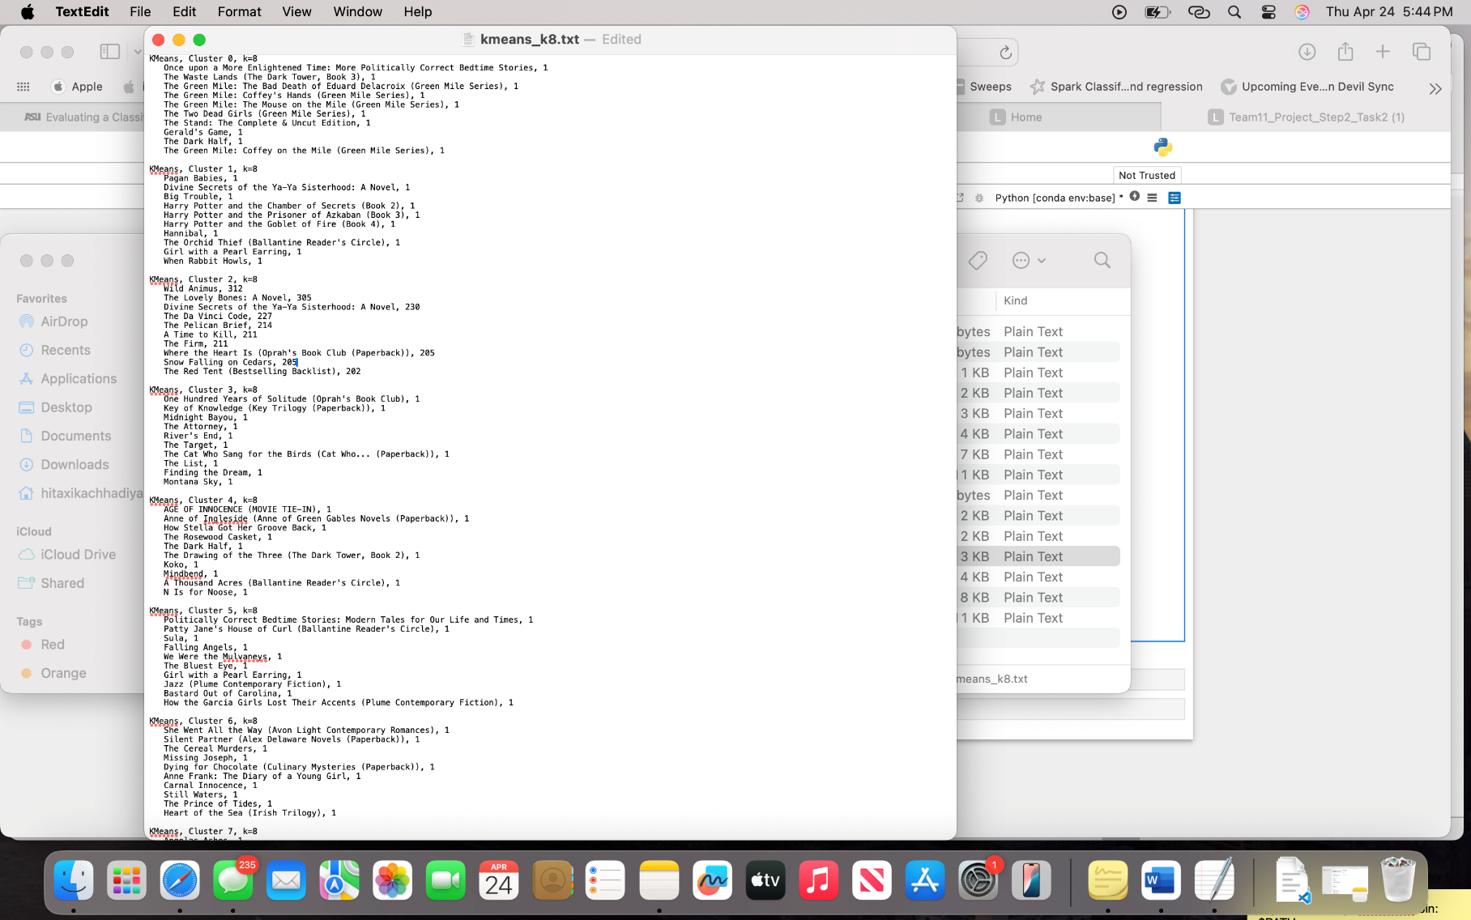

KMeans Clustering K= 10: Clusters 0 to 10 range from books that received very few ratings to very popular books that many people read and rated.

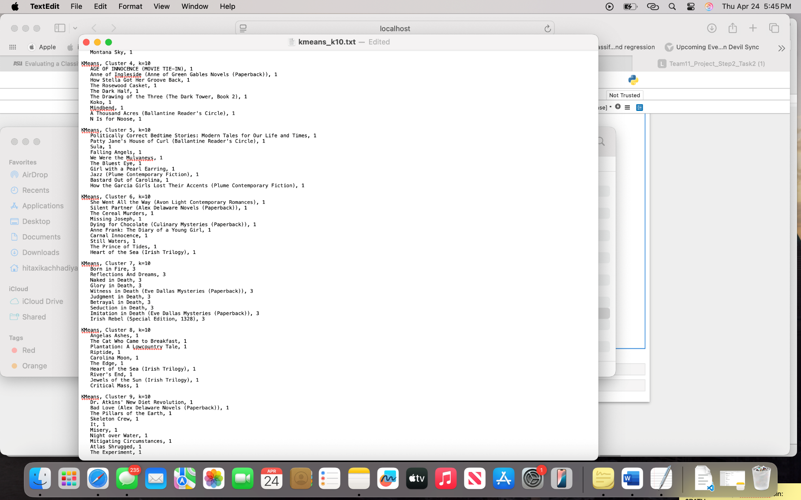

KMeans Clustering K= 20: Clusters 0 to 20 range from books that received very few ratings to very popular books that many people read and rated.

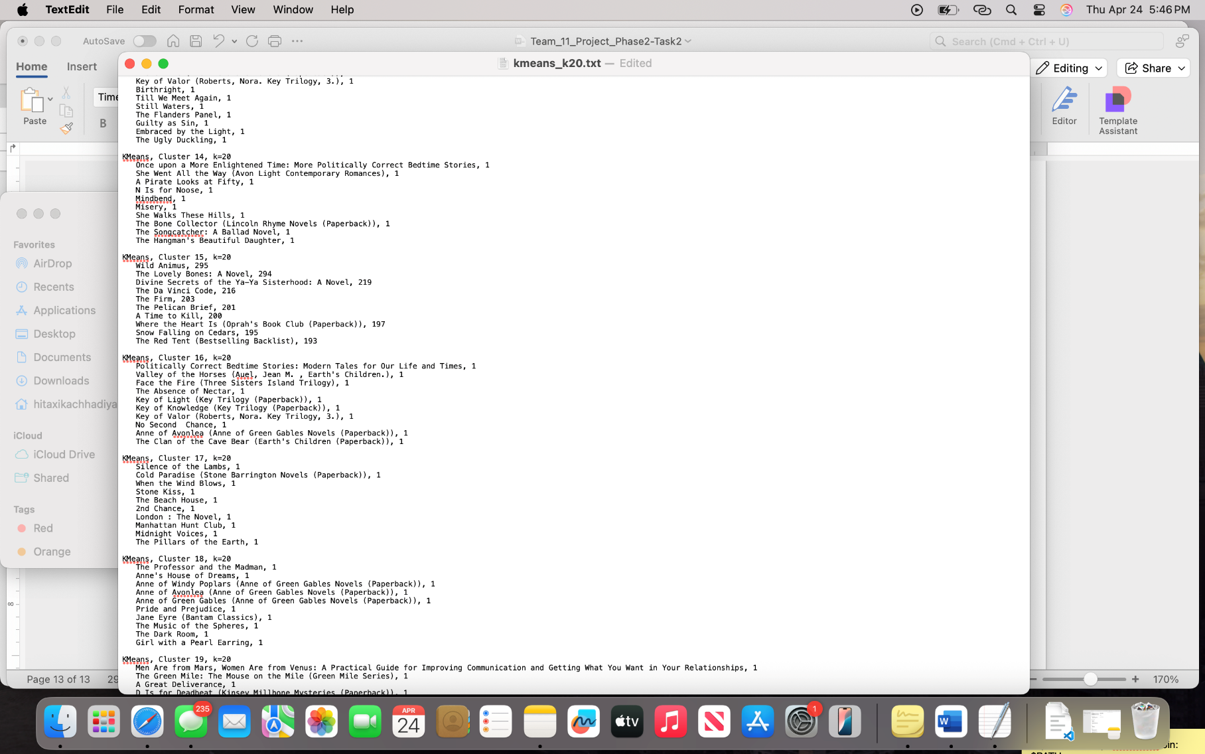

KMeans Clustering K= 30: Clusters 0 to 30 range from books that received very few ratings to very popular books that many people read and rated.

